BOTNET DETECTION FROM NETWORK TRAFFIC
[ A Machine Learning & Deep Learning Hybrid Approach ]
Team Members: Aakash Nimgaonkar, Aryan Jagani, Mansi Somnath Navale, Prathyusha Harish Kumar
Department of Information Systems, University of Maryland Baltimore County
734 Data Analytics for Cybersecurity

ABSTRACT
Botnets represent one of the most pervasive and evolving cybersecurity threats, enabling large-scale malicious activities such as distributed denial-of-service (DDoS) attacks, data theft, and unauthorized system control. Traditional signature-based detection systems often fail to identify new or rapidly evolving botnet behaviors, highlighting the need for intelligent, adaptive detection techniques. This study aims to design an automated system for detecting botnet-generated network traffic using NetFlow-based features. We begin by developing a machine learning baseline model using Random Forest, followed by a more advanced hybrid deep learning approach integrating Deep Neural Networks (DNN) and Long Short-Term Memory (LSTM) networks to capture both spatial and temporal dependencies in network flows.
The dataset consists of 5,472 flow-level records and 19 features. The hybrid model architecture and feature engineering were informed by the patterns and anomalies found through exploratory data analysis (EDA). A benchmark for accuracy and F1-score was set by the Random Forest baseline's impressive performance.
On the other hand, flow-based data frequently shows sequential patterns that are indicative of botnet activity. In order to take advantage of this, we created a hybrid DNN–LSTM architecture in which the LSTM records temporal dependencies in reshaped sequences while the DNN processes static tabular data. To generate predictions, both outputs were concatenated and run through a final dense layer. Although performance varied at higher epochs due to overfitting, the hybrid model showed encouraging results, with a test accuracy of over 82% in the first 30-epoch training. The complete approach, model architecture, evaluation outcomes, and conclusions are included in this report. The suggested approach offers scalability, automation, and adaptation for contemporary cybersecurity infrastructures while showcasing the potential of hybrid deep learning models for identifying intricate botnet behaviors.
- INTRODUCTION
Botnets are networks of compromised devices controlled by malicious actors to perform coordinated cyberattacks. Due to their distributed nature and ability to mimic normal network behavior, botnets are difficult to detect using traditional rule-based or signature-based methods. As cyberattacks grow in sophistication, machine learning and deep learning approaches offer more robust mechanisms for identifying subtle behavioral deviations within network traffic.
The goal of this research is to leverage flow-based data taken from network communication records to identify botnet activity. NetFlow-based analysis, in contrast to packet-level inspection, focuses on aggregated metadata including duration, byte rates, and packet counts, allowing for lightweight and scalable anomaly detection. There are two phases to the evolution of our work:
- Machine Learning Baseline: A Random Forest classifier is developed to establish baseline performance.
- Hybrid Deep Learning Model: A combined DNN–LSTM architecture is implemented to capture both feature interactions and sequential patterns.
Analyzing network traffic flows, developing predictive models, and assessing how well they differentiate between benign and malignant botnet flows are the goals.
II. RELATED WORK
Botnet detection has been widely studied across cybersecurity and machine learning domains. Traditional detection techniques include:
- Signature-based detection, which is ineffective against zero-day variants since it depends on known attack signatures.
- Anomaly-based detection, which tracks departures from typical behavior but frequently yields false positives.
- DNS and communication pattern analysis, which works well but has limitations when it comes to encrypted connections.
- Recent literature emphasizes machine learning and deep learning approaches:
- Random Forests and SVMs have been utilized for classification based on flow features due of its excellent interpretability, offering high interpretability.
- Deep Neural Networks (DNNs) enhance performance on tabular data by capturing nonlinear feature interactions.
- Recurrent Neural Networks (LSTM/GRU) are appropriate for time-dependent behavior detection because they model sequential dependencies in network flows.
- Hybrid models that combine CNN, DNN, or RNN architectures have demonstrated increased detection accuracy for changing attack patterns.
- By combining flow-based statistical features with temporal modeling using a novel hybrid DNN–LSTM neural architecture, our study expands on previous research and improves detection performance for botnet activity that changes over time.
III. METHODOLOGY
The three primary stages of the approach used in this work are performance evaluation, model creation, and data preprocessing. This methodical methodology guarantees robust model building, methodical treatment of network flow data, and equitable comparison between machine learning and deep learning methods.
We started loading and preparing NetFlow data from the provided figure by cleaning, normalizing, and dividing it into training and testing sets. Random Forest is used to analyze feature relevance. The best method for detecting botnets is determined by training and evaluating a variety of models, including Random Forest, DNN, LSTM, and Hybrid DNN–LSTM.
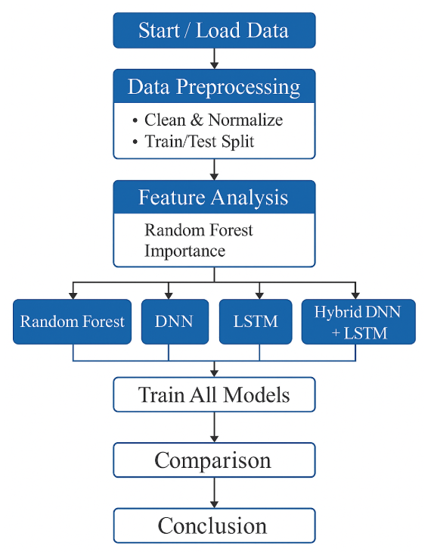
Fig: Flowchart
IV. DATASET DESCRIPTION
The dataset used in this study consists of 5,472 network flow records described by 19 NetFlow-based features. Every record is tagged as either regular or botnet-generated traffic and represents a condensed network communication session. Network identifiers like sender and target IP addresses and port numbers, traffic-related characteristics like duration, average duration, payload byte size (PBS), and total byte size (TBS), packet-level statistics like sent and received packets, transmission rate metrics like payload byte rate (PBR), average payload byte rate (AvgPBR), and total byte rate (TBR), and ratio-based indicators like the sender-to-receiver packet ratio (SRPR) are all included in the feature set. The target variable, class, is binary, with 0 representing regular traffic and 1 representing botnet activity.
V. DATA PREPROCESSING
A number of preprocessing techniques were used to guarantee data quality and model dependability. IP addresses and other non-informative and potentially biased identifiers were eliminated because they don't directly affect behavioral classification. To avoid training instability, missing values were found and addressed. StandardScaler, which converts features to zero mean and unit variance, a critical step for deep learning models, was used to normalize all numerical features. To allow for an objective assessment of performance, the dataset was then split into 80% training data and 20% testing data. To satisfy the sequential input requirements of recurrent neural networks, the feature vectors were transformed into a three-dimensional format for the LSTM-based models.
EXPLORATORY DATA ANALYSIS (EDA)
To comprehend the dataset's statistical properties and behavioral patterns, exploratory data analysis (EDA) was carried out. According to the data, payload byte rates are generally greater in botnet-generated flows than in regular traffic.
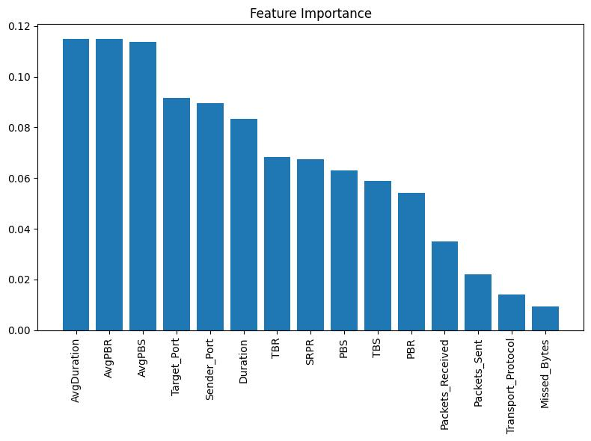
Fig: Feature Importance
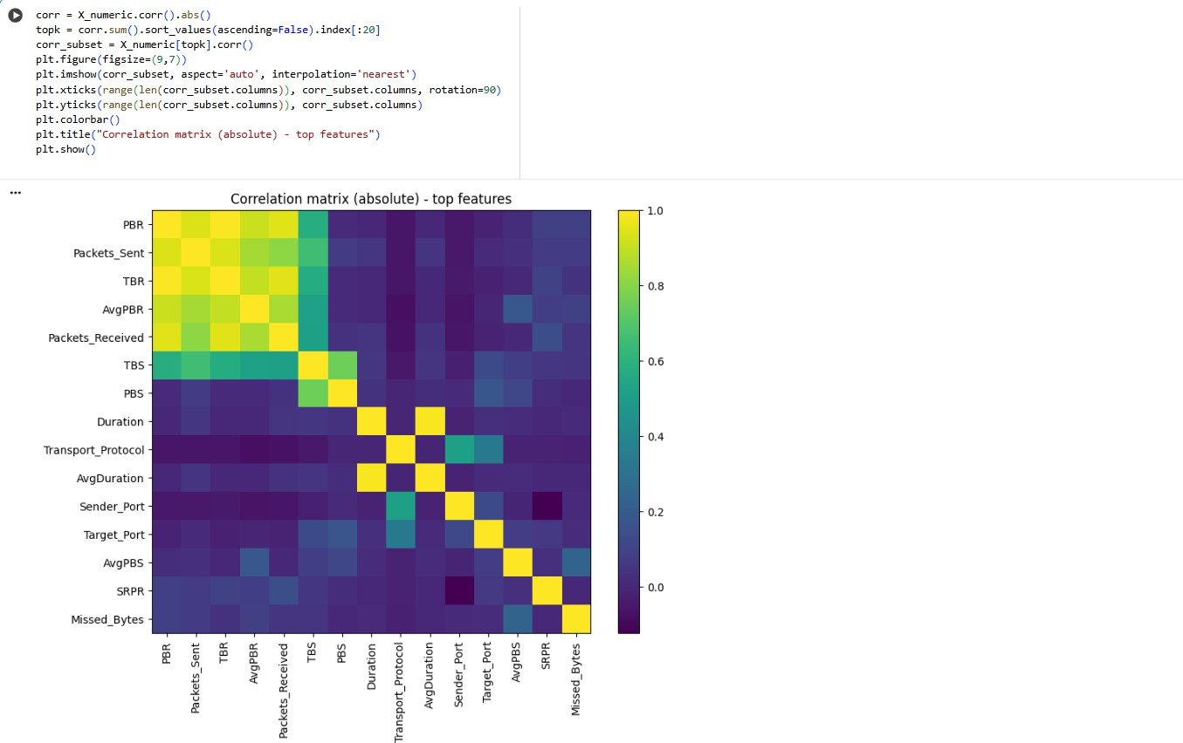

Fig: Correlation Matrix

There were also differences in the distributions of flow time between the harmful and benign classifications. Furthermore, measures related to packet ratios specifically, the sender-to-receiver packet ratio, emerged as powerful markers of anomalous behavior. To confirm these findings and direct feature priority and model selection, visual aids like histograms, correlation matrices, and feature distribution plots were employed.
BASELINE MACHINE LEARNING MODEL – RANDOM FOREST
A Random Forest classifier was implemented because of its stability, interpretability, and excellent performance on structured tabular data. To ensure balanced evaluation, 5-fold stratified cross-validation was employed, preserving class distribution across folds. The F1-score was chosen as the main assessment metric because it strikes a compromise between recall and precision, which is crucial in botnet detection since false negatives can be expensive. Deep learning models were compared to a robust baseline created by the Random Forest algorithm.
DEEP NEURAL NETWORK (DNN) MODEL
To discover intricate, non-linear correlations between static NetFlow features, the Deep Neural Network (DNN) model was created. DNNs work especially well with tabular datasets when classification results are influenced by interactions between various traffic variables. The DNN architecture used in this study is made up of several fully connected dense layers with Rectified Linear Unit (ReLU) activation functions after an input layer that corresponds to the number of preprocessed features. Higher-level abstractions of network traffic behavior can be captured by the model thanks to these layers.
The final output layer does binary classification using a sigmoid activation function, generating a probability score that indicates whether a certain network flow is created by a botnet or is normal. The Adam optimizer with binary cross-entropy loss was used to train the model, guaranteeing steady convergence and efficient gradient updates. Because unnormalized input values can result in unstable learning, feature scaling was essential for DNN performance. Strong performance on static flow-based datasets is provided by the DNN model, which acts as a bridge between sequential deep learning and conventional machine learning.
LONG SHORT-TERM MEMORY (LSTM) MODEL
The Long Short-Term Memory (LSTM) model was implemented to capture temporal and sequential patterns in network traffic flows that are often indicative of botnet behavior. Unlike traditional feedforward networks, LSTM networks maintain internal memory states that allow them to model long-term dependencies within sequential data. This capability is particularly relevant for detecting coordinated botnet activities such as periodic command-and-control communication and repeated attack patterns.
The preprocessed feature vectors were reshaped into a three-dimensional format that complied with LSTM input requirements in order to facilitate sequence learning. The model may learn temporal correlations among traffic features thanks to the LSTM architecture, which comprises of an input layer and an LSTM layer with a predetermined number of memory units. For binary classification, a dense layer with a sigmoid activation function receives the output from the LSTM layer.
To guarantee consistent evaluation, the model was trained using the Adam optimizer and binary cross-entropy loss, just like the DNN model. Even if the LSTM performed well, the amount of the dataset and the quality of the sequential representation affect how effective it is. However, it offers insightful information about temporal dependencies that static models are unable to capture.
HYBRID DEEP LEARNING MODEL – DNN–LSTM
A hybrid DNN–LSTM architecture was created to capture both temporal dependencies and static feature interactions in network data. Dense layers in the DNN branch are used to understand intricate nonlinear correlations between tabular flow features. The LSTM branch simultaneously models temporal patterns suggestive of coordinated botnet activity by processing altered input sequences.
To accomplish binary classification, the outputs of both branches are concatenated and run through a final dense layer that uses a sigmoid activation function. Accuracy was employed as a performance parameter after the model was trained using the Adam optimizer with binary cross-entropy loss. During training, EarlyStopping was used to reduce overfitting and enhance generalization.
VI. EXPERIMENTAL RESULTS
The machine learning and deep learning models utilized for botnet detection are thoroughly evaluated in this section. Classification accuracy, confusion matrices, ROC-AUC curves, and training behavior over several epochs are the foundation of the analysis.
Both sequential and static traffic factors are taken into consideration when interpreting the results. An 80–20 train–test split was used for all trials on the 5,472-record preprocessed NetFlow dataset. StandardScaler was used for feature normalization. Accuracy was the main parameter used to evaluate model performance; confusion matrices and ROC-AUC analysis were used to gauge classification reliability. Experiments were carried out over several epochs for deep learning models in order to track overfitting behavior and convergence tendencies.
RANDOM FOREST BASELINE RESULTS
The Random Forest classifier served as the baseline model and demonstrated the strongest overall performance on the static dataset. Using 5-fold stratified cross-validation, the model achieved an accuracy of 89%, outperforming all deep learning models in terms of raw accuracy.
The most significant factors in differentiating botnet traffic from regular flows, according to feature importance analysis, were packet- and byte-based characteristics such Payload Byte Rate (PBR), Packets Sent, Total Byte Size (TBS), and Sender-to-Receiver Packet Ratio (SRPR). Reliable identification of botnet activity was shown by the confusion matrix's high true-positive rate and comparatively low false-negative rate.

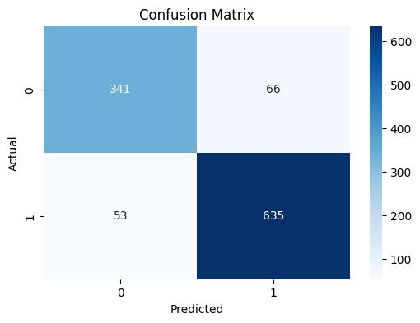

Fig: Confusion Matrix [Random Forest ]
The static nature of the dataset, where individual flow records are independent and do not require temporal modeling, is responsible for Random Forest's excellent performance. Nevertheless, Random Forest's application in dynamic real-world contexts is limited by its inability to mimic changing or sequential assault behaviors, despite its great accuracy.

DEEP NEURAL NETWORK (DNN) RESULTS
The Deep Neural Network model was created to use normalized NetFlow properties to learn non-linear feature interactions. Experiments were carried out over 30, 50, and 100 epochs, and as training went on, performance increased progressively.
DNN is the top-performing deep learning model in terms of absolute accuracy, reaching its maximum accuracy of 83.84% at 100 epochs. In comparison to LSTM-based models, the confusion matrix shows balanced classification performance across both classes with fewer false positives.
The DNN's robust performance demonstrates how deep feature learning works well with static flow-based data. Nevertheless, the DNN's capacity to identify coordinated botnet actions that develop over time is limited since, like Random Forest, it does not explicitly express temporal dependencies.
LONG SHORT-TERM MEMORY (LSTM) RESULTS
The goal of the LSTM model is to identify sequential and temporal patterns in network data. The LSTM was trained over several epochs to investigate temporal learning behavior after the input features were reshaped into a sequence-compatible format.
The poster illustrates the LSTM's accuracy of 83.38% after 50 epochs. After this, performance began to significantly deteriorate, signaling the beginning of overfitting. In comparison to earlier epochs, the confusion matrix shows better botnet flow detection, which is indicative of the LSTM's capacity to recognize recurring or periodic communication patterns frequently linked to botnet command-and-control activity.
The LSTM showed better recall for botnet traffic, a crucial feature in cybersecurity applications where missed detections are expensive, even if it did not outperform the DNN in raw accuracy.
HYBRID DNN–LSTM MODEL RESULTS
The hybrid DNN–LSTM model integrates feature-level learning and temporal modeling by combining the outputs of both architectures. Experimental results show that the hybrid model improved steadily with increased training:
- 30 epochs: 77.63%
- 50 epochs: 79.00%
- 100 epochs: 83.29%
The hybrid model's performance trend suggests that improved integration of spatial and temporal representations is made possible by extended training. In situations where sequential dependencies are significant, the confusion matrix demonstrates better botnet flow classification than solo LSTM.
The ROC curve further confirms strong discriminative capability, with a high AUC value, indicating robust separation between normal and botnet traffic. However, the decline observed in some configurations highlights the need for careful regularization, including EarlyStopping and dropout, to prevent overfitting.
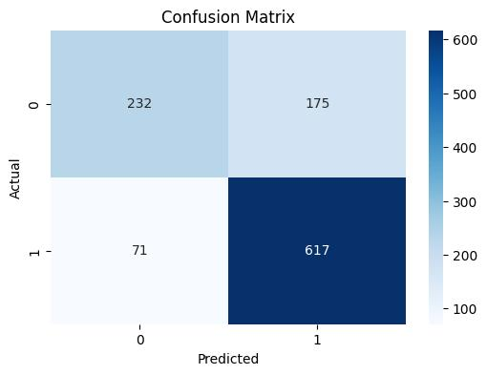

Fig: Confusion Matrix
[Hybrid DNN – LSTM ]

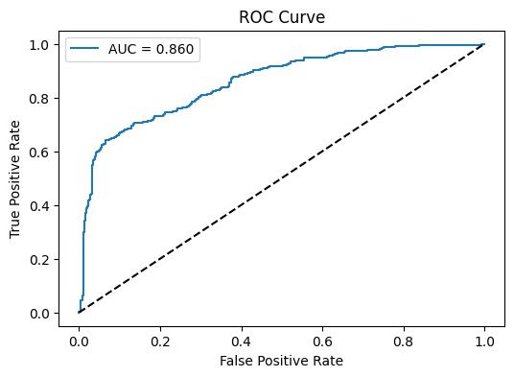
Fig: ROC Curve
[Hybrid DNN – LSTM ]

VII. COMPARATIVE ANALYSIS
A comparative analysis of all models reveals key insights:
- Random Forest (89%) attained the best accuracy since the dataset was static.
- DNN (83.84%) successfully learned feature-level interactions to attain the highest deep-learning accuracy.
- LSTM (83.38%) did well by identifying temporal trends.
- Hybrid DNN–LSTM (83.29%) demonstrated competitive performance while offering superior robustness for evolving traffic.
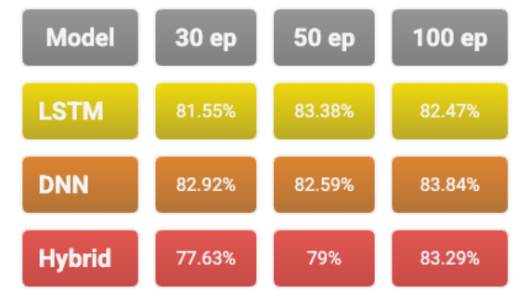
Fig: Model Comparison
In this dataset, Random Forest fared better than deep learning models, however it is not flexible enough to adjust to changing conditions. In comparison, the hybrid model is more suited for real-world deployment where network traffic is constantly changing because it captures both feature interactions and temporal relationships.
All assessed models had an overall accuracy of more than 80%, demonstrating the efficacy of deep learning and machine learning methods for botnet identification. Hybrid deep learning architectures offer more resilience and adaptability than standard models, which makes them a more dependable option for contemporary cybersecurity systems.
VIII. CHALLENGES
- Limited Dataset Size: There were only 5,472 flows in the dataset, which raised the possibility of overfitting, particularly for deep learning and hybrid models.
- Sequence Formation for LSTM: NetFlow data is inherently tabular, making it challenging to reshape into meaningful sequences for temporal learning.
- Overfitting in Hybrid Model: At higher epochs, the hybrid DNN–LSTM model's performance declined, necessitating cautious regularization and early halting.
- Class Similarity: Botnet traffic with low activity frequently looked like regular flows, which caused misclassification.
- Hyperparameter Tuning Complexity: It took a lot of time and computing power to optimize learning rates, dropout, and network depth.
IX. CONCLUSION
This study used NetFlow-based network traffic features to examine the efficacy of machine learning and deep learning algorithms for botnet activity detection. We assessed the suitability of Random Forest, Deep Neural Network (DNN), Long Short-Term Memory (LSTM), and a Hybrid DNN–LSTM architecture for botnet identification by examining both static and sequential features of network flows.
According to experimental results, all assessed models attained accuracy levels higher than 80%, demonstrating the suitability of data-driven methods for detecting hostile network activity. The Random Forest model's durability and efficacy on static datasets allowed it to obtain the greatest overall accuracy of 89%. The DNN outperformed other deep learning models in terms of accuracy, suggesting that feature-level learning is crucial in differentiating between botnet-generated flows and regular traffic. Sequence-aware learning is crucial for cybersecurity applications, as demonstrated by the LSTM model's great performance in capturing temporal dependencies.
Despite not outperforming Random Forest in terms of raw accuracy on this dataset, the hybrid DNN–LSTM model showed great promise by skillfully fusing temporal behavior modeling with spatial feature representations. Because of this, the hybrid architecture is better suited for real-world network environments where botnet behaviors are constantly changing and traffic patterns are dynamic. Overall, the findings show that hybrid deep learning models provide better adaptability and robustness for contemporary botnet detection systems, while traditional machine learning models are still useful for static analysis.
X. FUTURE WORK
While the results of this study are promising, several avenues exist for extending and enhancing the proposed system:
- Dataset Expansion and Diversity
The generalization and resilience of the model would be enhanced by expanding the dataset's size and variety to include real-world traffic and other botnet families.
- Attention-Based and Transformer Models
The model's capacity to concentrate on important temporal patterns and increase detection accuracy for intricate botnet behaviors could be improved by incorporating attention mechanisms or transformer-based architectures.

- Real-Time Botnet Detection
In order to assess latency, scalability, and operational viability, future research will concentrate on implementing the hybrid model in a real-time setting using streaming NetFlow data.
- Multiclass Botnet Classification
Forensic analysis and threat response would be enhanced by expanding the binary classification framework to detect particular botnet families, such as Zeus, Cutwail, and Mirai.
- Adaptive and Online Learning
By putting adaptive learning methods into place, the model could respond to new attack patterns without requiring complete retraining.
- Improved Regularization and Interpretability
To increase model transparency and confidence in cybersecurity operations, more research will examine explainable AI methodologies and sophisticated regularization strategies.
In summary, this study provides a solid basis for intelligent botnet identification with hybrid deep learning models. The suggested method has the potential to be a useful part of next-generation network security systems with additional improvements and practical validation.

XI. REFERENCES
- I. Ghafir, V. Prenosil, M. Hammoudeh, T. Baker, S. Jabbar, and S. Khalid, “BotDet: A System for Real-Time Botnet Command and Control Traffic Detection,” IEEE Security & Privacy, vol. 16, no. 4, pp. 60–68, 2018.
- P. J. Denning and D. E. Denning, ‘‘Discussing cyber attack,’’ Commun. ACM, vol. 53, no. 9, pp. 29–31, 2010.
- W. Sturgeon, ‘‘Net pioneer predicts overwhelming botnet surge,’’ CENET Mag., San Francisco, CA, USA, Tech. Rep., Jan. 2007.
- S. García, A. Zunino, and M. Campo, ‘‘Survey on network-based botnet detection methods,’’ Secur. Commun. Netw., vol. 7, no. 5, pp. 878–903, 2014
- S. Behal, A. S. Brar, and K. Kumar. (2010). Signature-Based Botnet Detection and Prevention. [Online]. Available: http://www.rimtengg. com/iscet/proceedings/pdfs/advcomp/148.pdf
- S. Arshad, M. Abbaspour, M. Kharrazi, and H. Sanatkar, ‘‘An anomalybased botnet detection approach for identifying stealthy botnets,’’ in Proc. IEEE Int. Conf. Comput. Appl. Ind. Electron. (ICCAIE), Dec. 2011, pp. 564–569.
- F. Hussain et al., "A Two-Fold Machine Learning Approach to Prevent and Detect IoT Botnet Attacks," in IEEE Access, vol. 9, pp. 163412-163430, 2021, doi: 10.1109/ACCESS.2021.3131014.
- M. W. Nadeem, H. G. Goh, Y. Aun and V. Ponnusamy, "Detecting and Mitigating Botnet Attacks in Software-Defined Networks Using Deep Learning Techniques," in IEEE Access, vol. 11, pp. 49153-49171, 2023, doi: 10.1109/ACCESS.2023.3277397.
- S. N. Ali Shah, G. Ahmed, A. Akhunzada and E. S. Siddiqui, "A Novel Deep Learning-based Approach to encounter cyber threats in IIoT," 2022 Mohammad Ali Jinnah University International Conference on Computing (MAJICC), Karachi, Pakistan, 2022, pp. 1-7, doi: 10.1109/MAJICC56935.2022.9994173.
- W. Jian et al., "SA-Bi-LSTM: Self Attention With Bi-Directional LSTM-Based Intelligent Model for Accurate Fake News Detection to Ensured Information Integrity on Social Media Platforms," in IEEE Access, vol. 12, pp. 48436-48452, 2024, doi: 10.1109/ACCESS.2024.3382832.
- S. P. Mary, M. D. Anto Praveena, A. M. J, D. U. Nandini and R. S. Bama Krishna, "Assessing Lifespan of Lithium-Ion Rechargeable Batteries through Hybrid CNN-LSTM-DNN Method," 2023 International Conference on Circuit Power and Computing Technologies (ICCPCT), Kollam, India, 2023, pp. 325-329, doi: 10.1109/ICCPCT58313.2023.10245400.
- P. C. Tikekar, S. S. Sherekar and V. M. Thakre, "Features Representation of Botnet Detection Using Machine Learning Approaches," 2021 International Conference on Computational Intelligence and Computing Applications (ICCICA), Nagpur, India, 2021, pp. 1-5, doi: 10.1109/ICCICA52458.2021.9697320.
- T. Al-Shurbaji et al., "Deep Learning-Based Intrusion Detection System for Detecting IoT Botnet Attacks: A Review," in IEEE Access, vol. 13, pp. 11792-11822, 2025, doi: 10.1109/ACCESS.2025.3526711.

